Introduction:

This project explores global military expenditure trends from 1960 to 2018. Using historical data sourced from Kaggle, the aim is to identify top spenders, observe regional and temporal patterns, and understand how military budgets have evolved. Through data wrangling, exploratory data analysis (EDA), and interactive visualizations, the report highlights key insights into global defense priorities over nearly six decades.

Objectives:

* To identify countries/regions with the highest and lowest military expenditures.
* To analyze spending patterns across decades.
* To compare expenditure trends between countries and groups (e.g., high-income vs low-income).
* To determine which countries increased spending most in recent years.
* To quantify the percentage share of global military expenditure contributed by top spenders.

Key Findings:

* **Top Spender:** The United States consistently had the highest military expenditure.
* **Lowest Spender:** Mauritius recorded the lowest total military expenditure.
* **Most Recent Growth:** Some countries, like Saudi Arabia and China, showed a sharp increase in the last 10 years.
* **Peak Spending Year:** 2015 saw the highest global military expenditure.
* **Decade Trend:** Military expenditure has shown a rising trend across each decade.
* **Spending Concentration:** Top 5 countries account for a significant portion (e.g., ~60%+) of global military spending.

Visual Summaries:

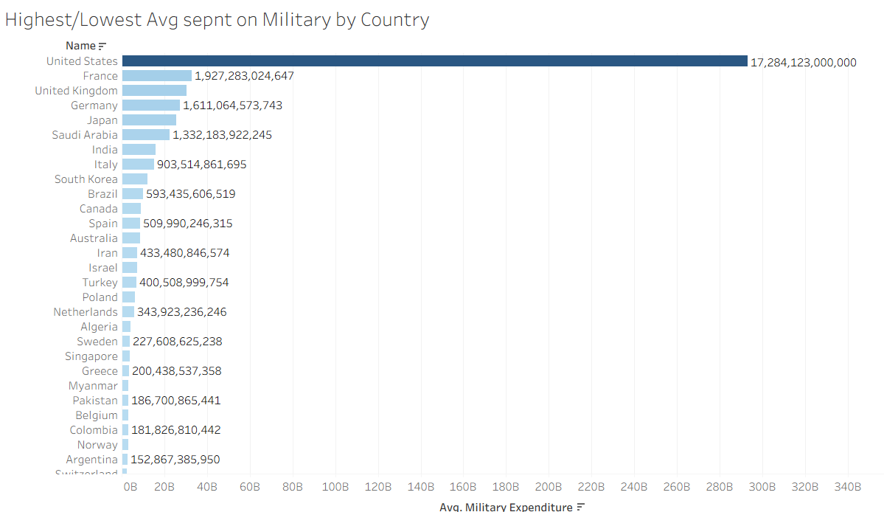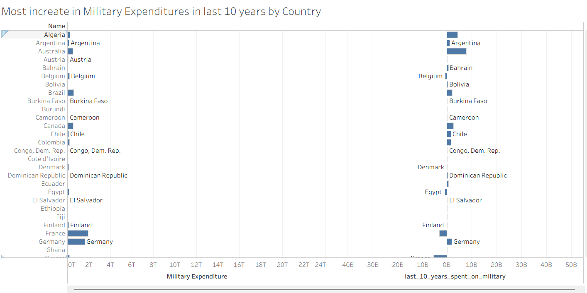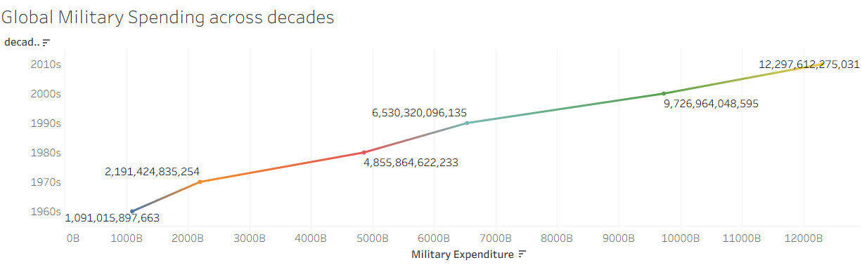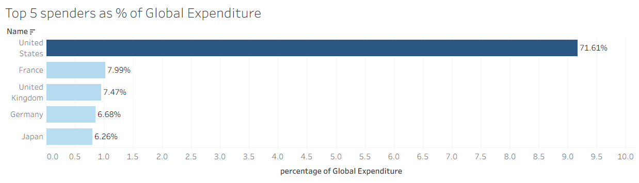

Conclusion:

The analysis highlights a steady rise in global military expenditure over the decades, driven primarily by a few dominant countries. While some regions have maintained consistent investment, others have experienced recent growth due to geopolitical shifts or changing priorities. Understanding these trends can help policymakers, researchers, and global organizations assess security dynamics and defense strategies.

**Why the Questions in the Documentation Were Chosen**:

The selected questions were chosen to cover a broad yet insightful range of perspectives on military spending. They highlight not just who spends the most, but how that spending changes over time, how it compares across income groups or regions, and which nations have experienced rapid growth. These questions support both a macro (global/decade) and micro (country-specific) understanding of defense expenditure patterns.